SmartSQL

User Manual

* When a new User enters the home page of the smartSQL.
* 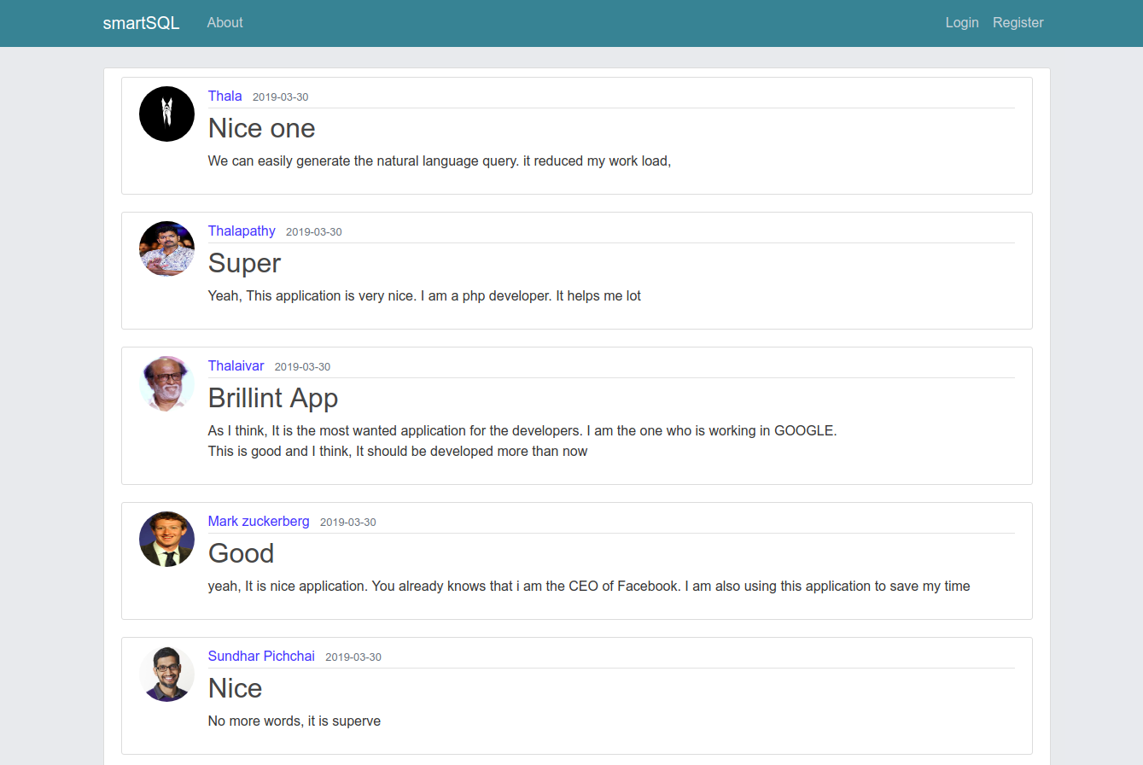User will see the all reviews of smartSQL users
* It will help them to understand the sql to their problems.
* Person can register a new account to become a user Using register page.
* 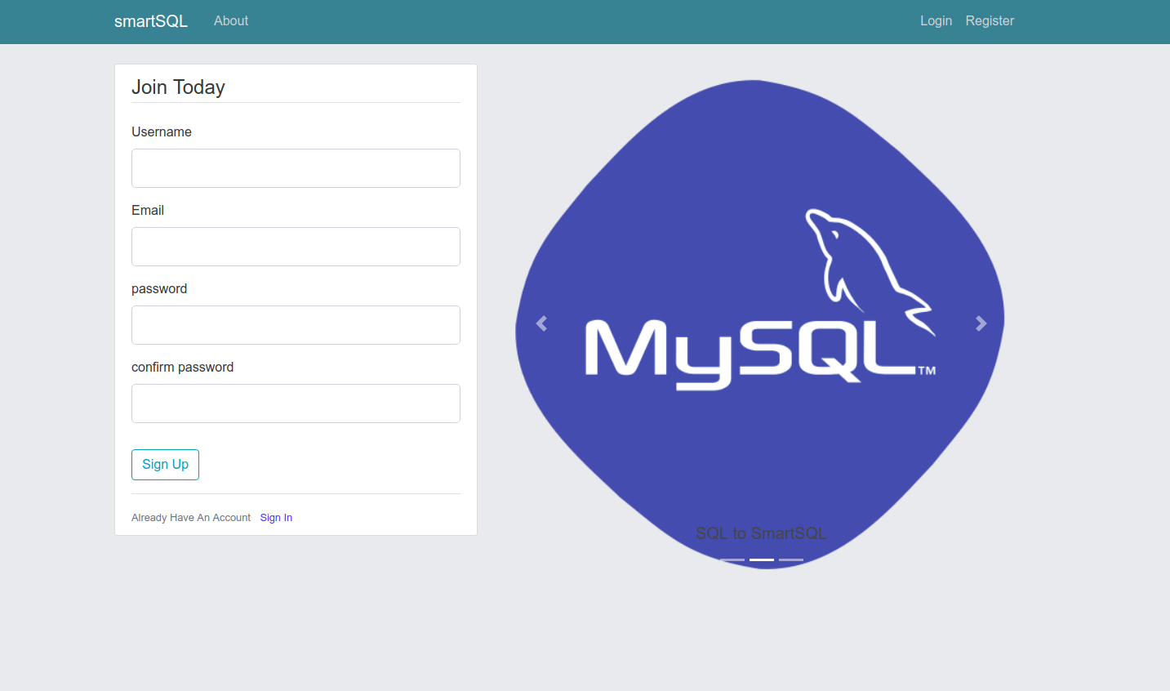After registration the user will be redirected to profile page.

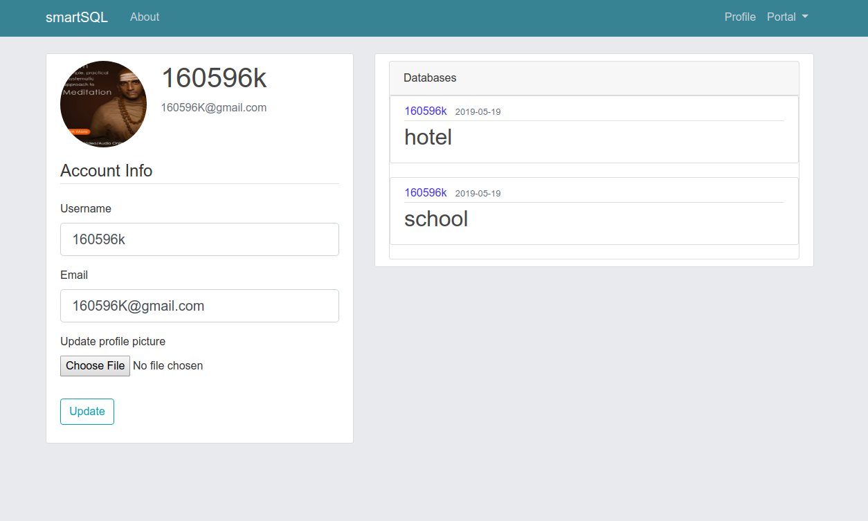

* In the profile page, users can change their the information simple way and database schemas which has been uploaded by user will have been displayed. User can clicks the schema to view the tables and columns in new page which as referred as schema page.

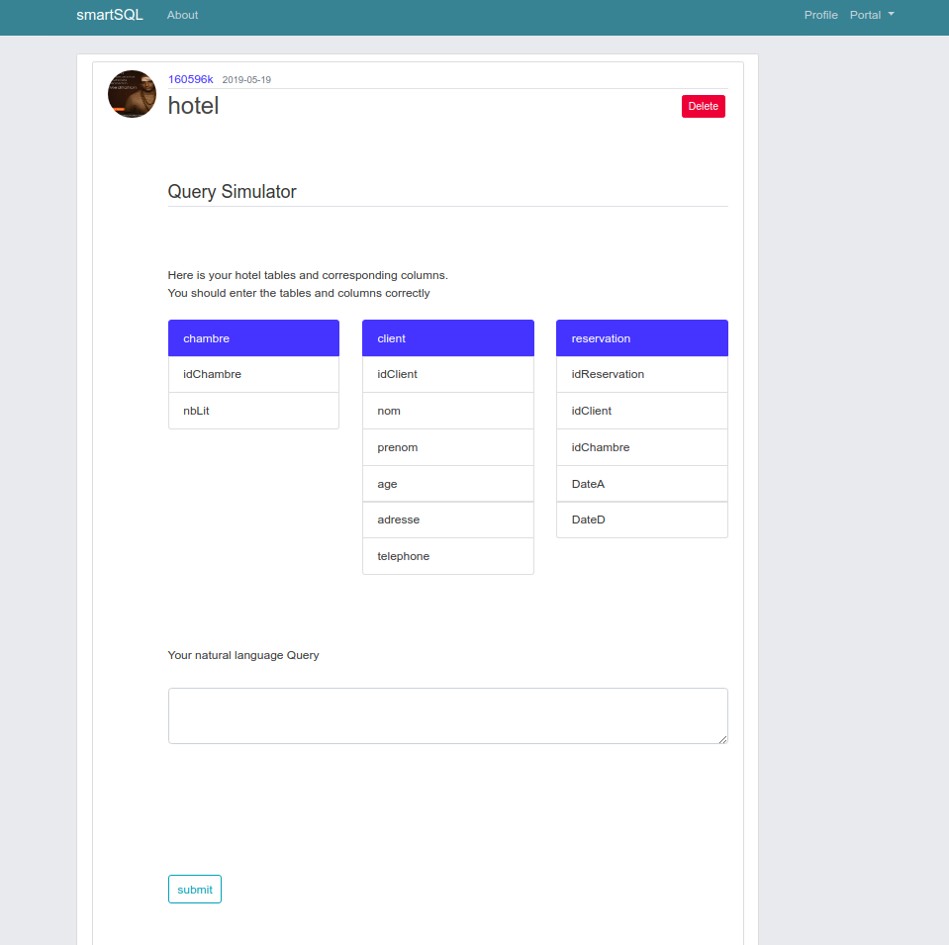

* In the schema page, user can type the natural language query and submit to the system. System will send this to the ln2sql. Ln2sql takes the natural language query and parses it using database schema. The result which has been produced by ln2sql will be displayed in the same window.

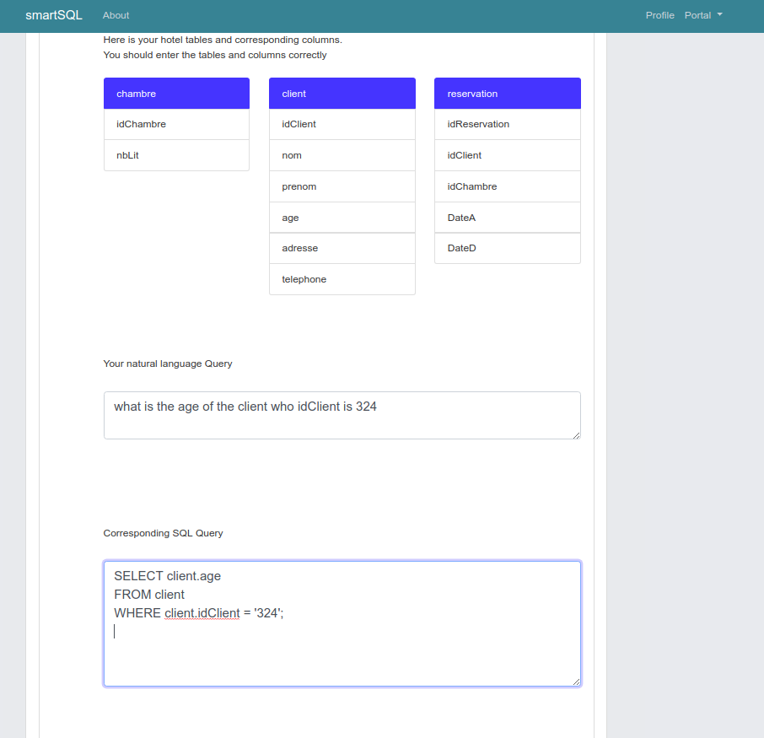

* 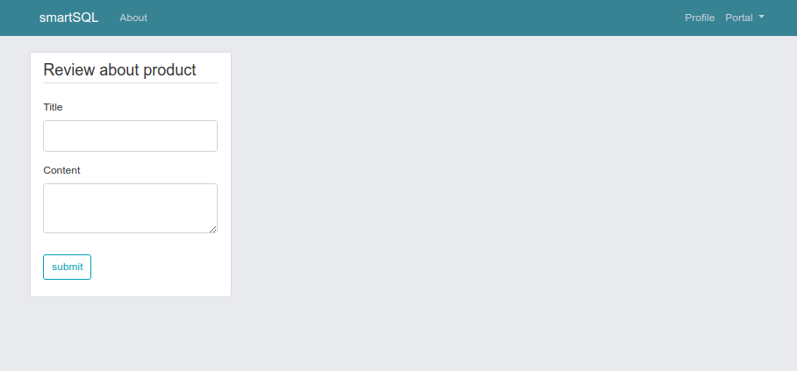User can rate the product and it will be displayed in homepage and all users using review page